29.09.26 PARTIAL IMPLEMENTATION
AIM:
To design, develop, and partially implement "CivicConnect" - a web-based civic complaint management, public service delivery, and departmental resolution tracking platform. The system empowers citizens to report municipal grievances (such as road damage, sanitation lapses, water leakages, and broken streetlights) directly to municipal authorities with photo evidence, provides real-time lifecycle tracking across transparent stages (Submitted -> Assigned -> In Progress -> Resolved/Rejected), facilitates automated department allocation and field officer resolution dispatch, supports citizen satisfaction feedback ratings, and equips municipal administrators with operational monitoring dashboards and analytical reports.
PROJECT DETAIL:
Project Details
Item | Details
Project Title | CivicConnect - Civic Complaint Management & Public Service Platform
Technology Stack | HTML5, CSS3, JavaScript (ES6+), React 18, Vite, Node.js, Express.js, MySQL, SQLite, JWT, Multer
Frontend Server | Vite Development Server (Port 3000 / 3001)
Backend Server | Node.js Express REST API (Port 5000)
Database | MySQL 8.0 (Primary) with Zero-Config Embedded SQLite Fallback (civicconnect.db)
Development Environment | Visual Studio Code, Node.js (v20+), Windows 11
Architecture | Three-Tier Web-based Client-Server Architecture with Decoupled REST APIs
Authentication | Role-Based Access Control (RBAC) and JWT Session Management with bcryptjs
Main Users | Citizen, Government Department Officer, Municipal Administrator, Public Guest

Technology Stack and Architecture:
Layer | Technology / Purpose
Frontend | React 18 Single Page Application (SPA), HTML5, JavaScript (ES6+), Vite Dev Server
UI Design | Custom CSS3 with responsive dashboards, status badges, and Lucide React icons
State & Navigation | React Router v6 for Protected Role Routes; React Context API (AuthContext)
Backend | Node.js with Express.js Modular RESTful Architecture
Database Connectivity | Promisified sqlite3 query adapter & mysql2 connection pool
Database | MySQL 8.0 (6 normalized relational tables) with fallback to embedded SQLite (civicconnect.db)
File Upload Handling | Multer middleware for multipart/form-data complaint photo uploads and validation
Authentication | JSON Web Tokens (JWT) in Authorization Bearer headers, bcryptjs (10 salt rounds)
Notification Dispatcher | Automated in-app notification alerts on complaint submission, assignment, and status updates
Architecture | Three-Tier Client-Server Web Architecture with Decoupled RESTful APIs

CODE SNIPPETS:
- ROLE-BASED AUTHENTICATION & JWT VERIFICATION MIDDLEWARE:
const jwt = require('jsonwebtoken');
const JWT_SECRET = process.env.JWT_SECRET || 'civicconnect_secret_key_12345';
const verifyToken = (req, res, next) => {
const authHeader = req.headers['authorization'];
if (!authHeader) {
return res.status(401).json({ message: 'Access denied. No token provided.' });
}
}
try {
const decoded = jwt.verify(token, JWT_SECRET);
req.user = decoded;
next();
} catch (err) {
return res.status(403).json({ message: 'Invalid or expired token.' });
}
};
2. RELATIONAL DATABASE CONNECTION & PROMISIFIED QUERY ADAPTER:
const sqlite3 = require('sqlite3').verbose();
const db = new sqlite3.Database(dbPath, (err) => {
if (err) console.error('Error connecting to SQLite database:', err.message);
else console.log('Connected to CivicConnect SQLite database at:', dbPath);
});
const query = (sql, params = []) => {
return new Promise((resolve, reject) => {
db.all(sql, params, (err, rows) => {
if (err) reject(err);
else resolve(rows);
});
});
};
3. CITIZEN GRIEVANCE SUBMISSION & AUDIT TRAIL LOGGING:
const submitComplaint = async (req, res) => {
try {
const { title, description, category, location, priority } = req.body;
const citizenId = req.user.id;
if (!title || !description || !category || !location) {
return res.status(400).json({ message: 'Please fill all required complaint fields.' });
}
await run(
`INSERT INTO complaints (complaint_id, citizen_id, title, description, category, location, complaint_date, priority, status, image_path)
return res.status(201).json({ message: 'Complaint submitted successfully!', complaintId });
} catch (err) {
return res.status(500).json({ message: 'Error submitting complaint.' });
}
};
4. GOVERNMENT OFFICER STATUS UPDATE & RESOLUTION LIFECYCLE:
const updateComplaintStatus = async (req, res) => {
try {
const { id } = req.params;
const validStatuses = ['Assigned', 'In Progress', 'Resolved', 'Rejected'];
if (!validStatuses.includes(status)) {
return res.status(400).json({ message: 'Invalid status value.' });
}
if (status === 'Resolved') {
if (!resolution_description || resolution_description.trim() === '') {
return res.status(400).json({ message: 'Resolution description is required for Resolved status.' });
}
} else {
await run(
`UPDATE complaints SET status = ?, officer_id = ?, updated_at = ? WHERE complaint_id = ?`,
[status, officerId, nowFormatted, id]
);
}
5. MUNICIPAL ADMIN DEPARTMENT ALLOCATION & ANALYTICS REPORTING:
const assignComplaint = async (req, res) => {
try {
const { id } = req.params;
const { department_id, officer_id, remarks } = req.body;
const adminId = req.user.id;
const deptName = dept ? dept.department_name : 'relevant department';
await run(
`INSERT INTO notifications (user_id, complaint_id, message, is_read) VALUES (?, ?, ?, 0)`,
[complaint.citizen_id, id, `Complaint ${id} has been assigned to ${deptName}.`]
);
return res.status(200).json({ message: 'Complaint assigned successfully.' });
} catch (err) {
return res.status(500).json({ message: 'Error assigning complaint.' });
}
};
SCREEN SHORTS:
1. HOME AND LANDING PAGE:
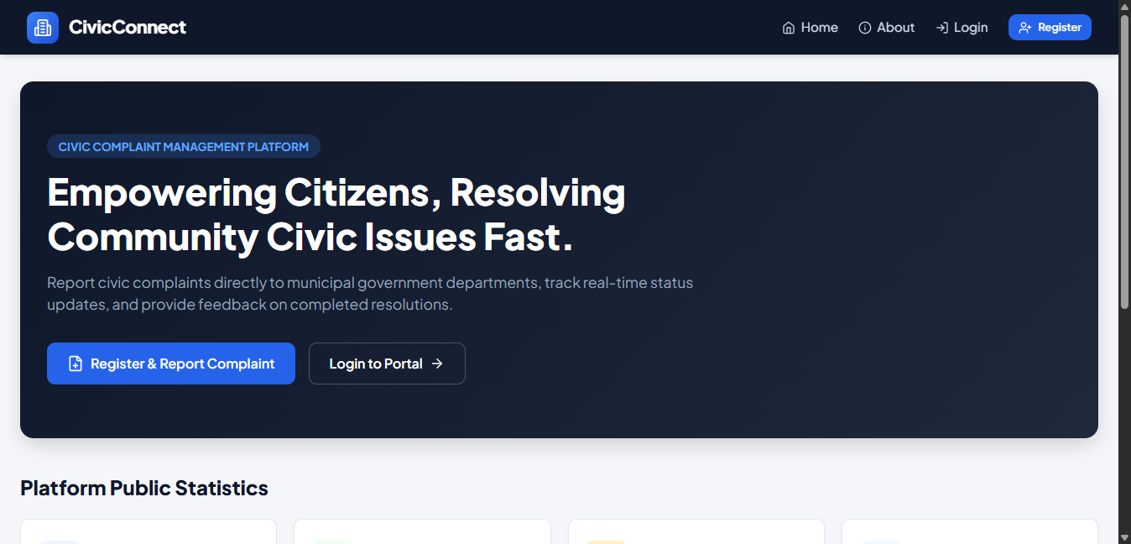
Public home portal displaying live civic grievance metrics, municipal department overviews, and quick action shortcuts for citizen engagement.

2. END-TO-END:
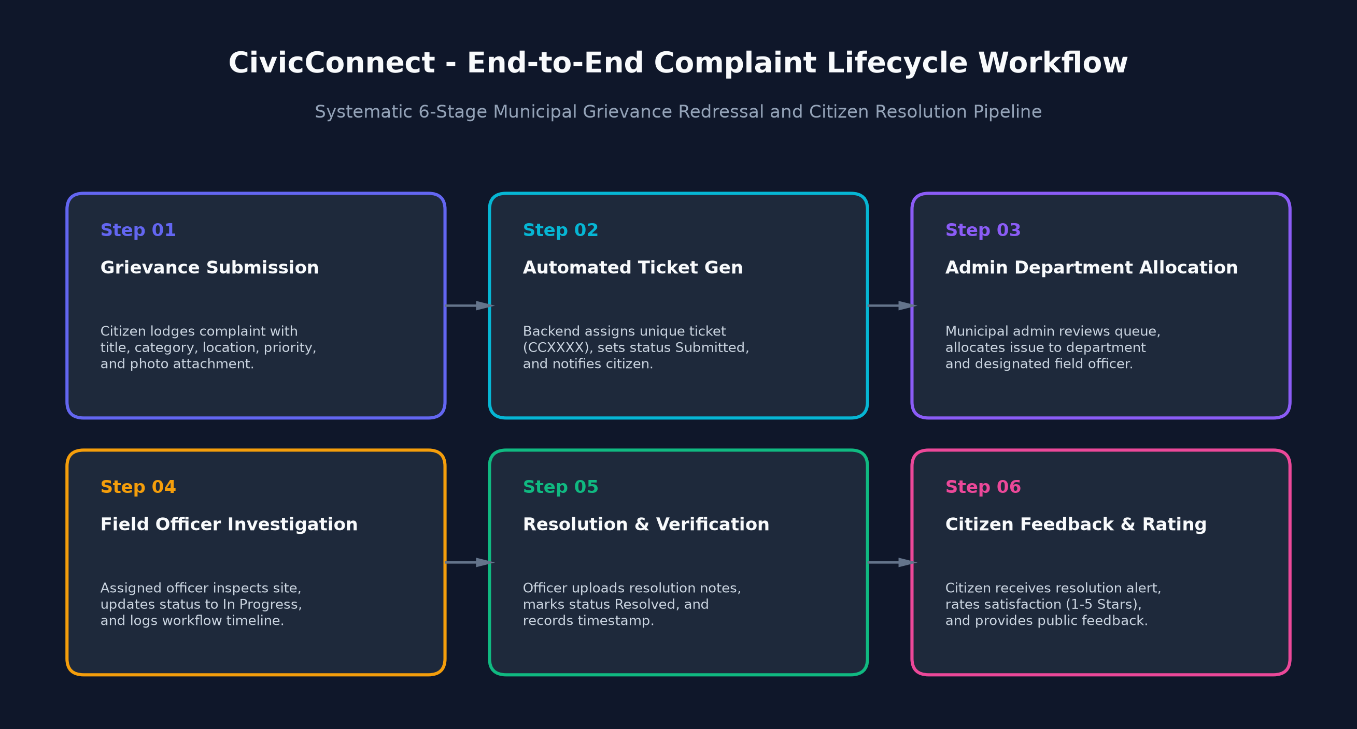
Systematic 6-stage lifecycle illustrating citizen complaint registration, automatic ticket generation, department allocation, officer investigation, resolution, and citizen feedback.
3. LOGIN:
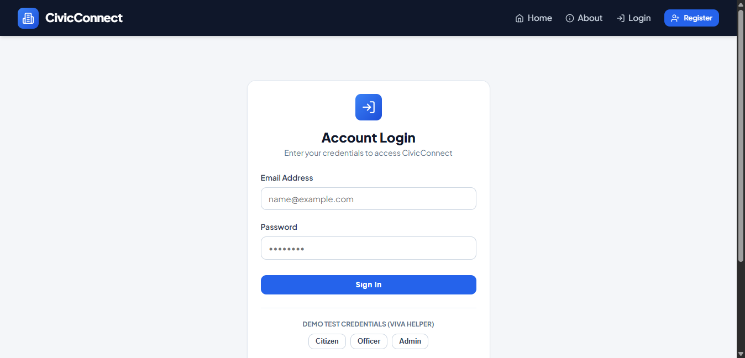
Secure multi-role authentication portal featuring JWT credential validation and 1-click viva testing demo switchers for Citizen, Officer, and Admin access.
4. ARCHITECTURE:
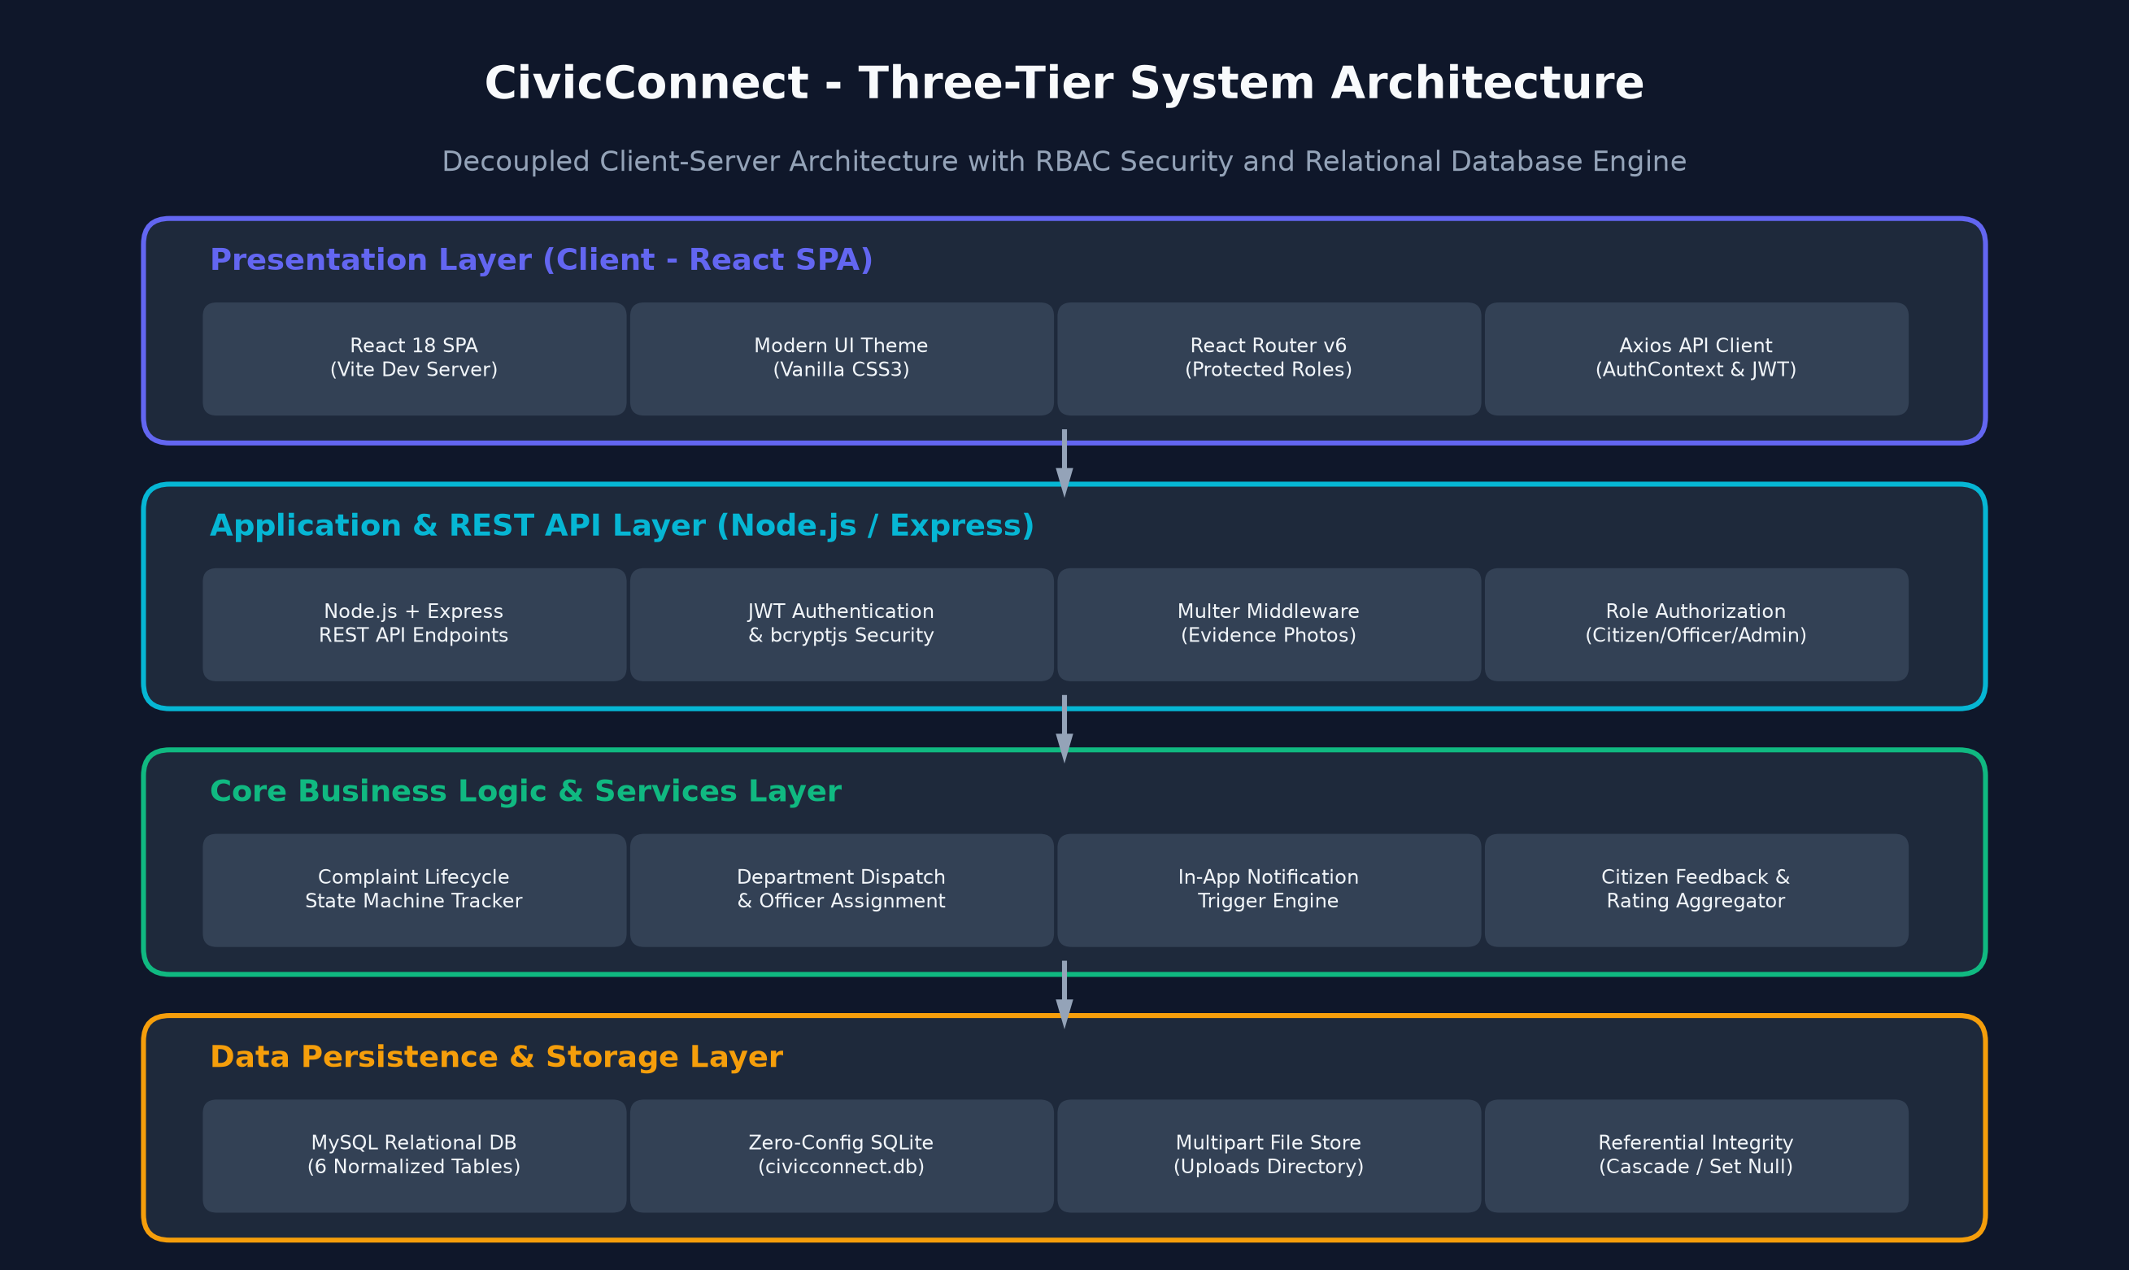
Modular three-tier system architecture diagram showing the React SPA presentation layer, Express REST API layer, business logic services, and hybrid MySQL/SQLite database engine.
5. USER LOGIN SCREENSHORTS
5.1 CITIZEN DASHBOARD & STATS OVERVIEW:
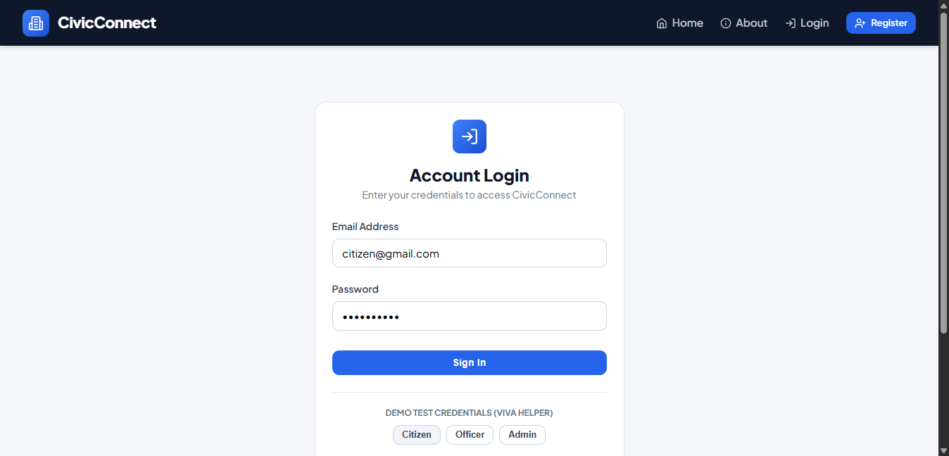
Citizen personal workspace showing grievance summary counters (Total, In Progress, Resolved), quick complaint links, recent activity, and latest notifications.
5.2 GRIEVANCE SUBMISSION WITH EVIDENCE UPLOAD:
Citizen grievance filing interface featuring category selection, priority flags, exact location details, description textarea, and photo evidence upload.
5.3 CITIZEN COMPLAINT TRACKER & STATUS TIMELINE:
Complaint tracking roster with unique ticket IDs (CCXXXX), category badges, submission dates, current status tags, and detail view navigation.
5.4 GOVERNMENT OFFICER DASHBOARD & WORKSPACE:
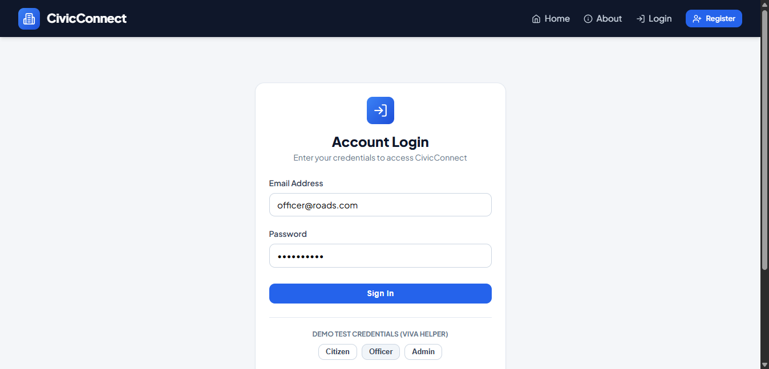
Officer operational dashboard highlighting pending departmental issues, high-priority grievances, quick status update shortcuts, and department info.
5.5 OFFICER ASSIGNED COMPLAINT RESOLUTION QUEUE:
Departmental grievance queue allowing field officers to filter tickets, review citizen descriptions and photos, update status, and log resolution descriptions.
5.6 MUNICIPAL ADMIN CENTRAL DASHBOARD:
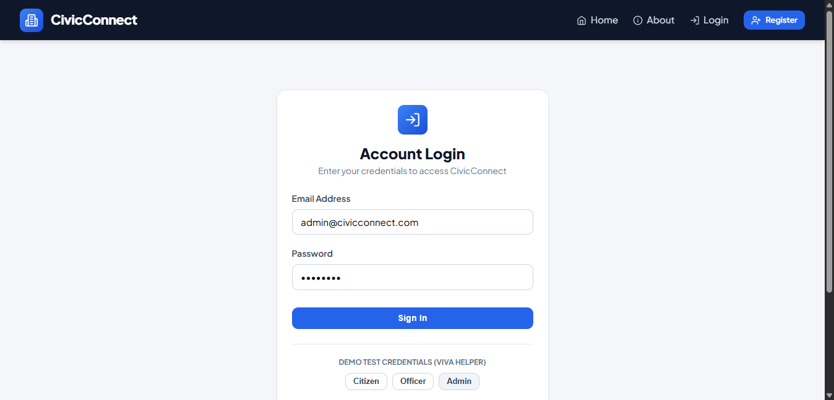
Administrative command center monitoring platform-wide grievance metrics, registered citizens, active department officers, and feedback ratings.

5.7 MUNICIPAL DEPARTMENT MANAGEMENT:
Department administrative management module for creating municipal departments, updating descriptions, and reviewing departmental assigned grievances.
5.8 ADMIN COMPLAINT ALLOCATION & MANAGEMENT:
Central grievance control module enabling administrators to allocate incoming unassigned complaints to specific departments and designated officers.
5.9 OPERATIONAL ANALYTICS & PLATFORM REPORTS:
Municipal analytics dashboard displaying visual status breakdowns, department performance metrics, category distribution, and average citizen satisfaction ratings.

5.10 CITIZEN & OFFICER USER DIRECTORY MANAGEMENT:
User management console providing oversight of registered citizens and department officers with account creation and active/inactive status toggles.
5. WHAT IS DONE
- Requirements specification and municipal complaint use-cases: Comprehensive software requirement specification (SRS), system architecture, and entity relationship diagrams.
- Relational database design: Normalized database schema comprising 6 core tables (departments, users, complaints, complaint_status_history, notifications, feedback) with foreign keys and cascade integrity.
- Zero-configuration dual database support: Primary MySQL engine with seamless SQLite embedded fallback (civicconnect.db) for instant portability and viva demonstration.
- Role-Based Access Control (RBAC): Four distinct personas implemented - Citizen, Government Department Officer, Municipal Administrator, and Public Guest.
- Security & Session management: JWT (JSON Web Tokens) with bcryptjs password encryption (10 salt rounds) and role authorization middlewares (isCitizen, isOfficer, isAdmin).
- Citizen registration & profile management: Citizen sign-up, password modification, profile details, and contact number management.
- Grievance submission module: Form validation for title, category, priority, location, detailed description, and evidence photo upload via Multer.
- Automated Complaint Ticketing: Unique CCXXXX tracking ticket generation for indexing and fast public reference.
- Multi-stage complaint lifecycle: Sequential state transitions (Submitted -> Assigned -> In Progress -> Resolved / Rejected).
- Audit trail status logging: Dedicated history table recording every status update, timestamps, remarks, and user IDs.
- Government officer dashboard: Department-level complaint queue, priority badges, and status filtering.
- Field officer resolution workflow: Work status updates (In Progress, Resolved, Rejected) with mandatory resolution notes.
- Municipal administrator control center: Platform monitoring, new department officer account creation, and user active/inactive toggles.
- Department management: Creation, updating, and oversight of municipal departments (Roads, Sanitation, Water, Electricity).
- Complaint assignment system: Administrative tools to allocate grievances to relevant departments and designated officers.
- Citizen feedback & rating system: 1 to 5 star rating submission and satisfaction review on resolved complaints.
- In-app notification system: Automated real-time alerts dispatched on complaint submission, department assignment, and status transitions.
- Operational analytics & reporting: Visual breakdown and summary statistics of complaints by status, category, department, and citizen ratings.
- Modern frontend UI: Responsive Single Page Application (SPA) built with React 18 (Vite), Vanilla CSS3, custom cards, and Lucide React icons.
6. WHAT NEEDS TO BE DONE
- Interactive GIS Map Integration: Visual geospatial mapping of civic complaints using Leaflet / Google Maps API to display heatmaps and location clusters.
- AI-Powered Duplicate Complaint Detection: Computer vision and NLP text similarity matching to cluster identical grievances submitted from the same vicinity.
- Automated Department Routing: Machine learning text classification to automatically categorize and route complaints to the appropriate department.
- External SMS & WhatsApp Notifications: Integration with Twilio / WhatsApp Business API for instant external SMS alerts to citizens on status milestones.
- Citizen Geolocation Auto-Detection: Browser HTML5 GPS geolocation auto-fill during grievance submission for accurate location tagging.
- PDF Resolution Certificate & Work Order: Generating printable municipal work orders and completion reports with official digital stamps.
- Public Transparency Leaderboard: City-wide ward rankings, departmental resolution SLAs, and public performance scorecards.
- Offline-First Mobile Application: Progressive Web App (PWA) / React Native mobile app with offline photo caching for citizens in low-connectivity areas.
- IoT Smart Sensor Integration: Automated ticket creation triggered by smart waste bin fullness sensors and water pipe flow meters.
- Production Cloud Deployment & CI/CD: Containerization with Docker, managed MySQL on AWS RDS, and automated CI/CD pipeline on AWS / Render.
- Security Audits & Load Testing: OWASP Top 10 security hardening, CSRF protection, and high-concurrency stress testing.

